Test Case 1 – Flipkart Homepage
Test Case ID: WB01
Test Case: Verify Flipkart homepage is displayed
Test Steps: Open the Flipkart website in the browser.
Expected Result: Flipkart homepage should be displayed with search bar, Login, Cart and product categories.
Actual Result: Flipkart homepage was displayed successfully with search bar, Login, Cart and product categories.
Status: PASS
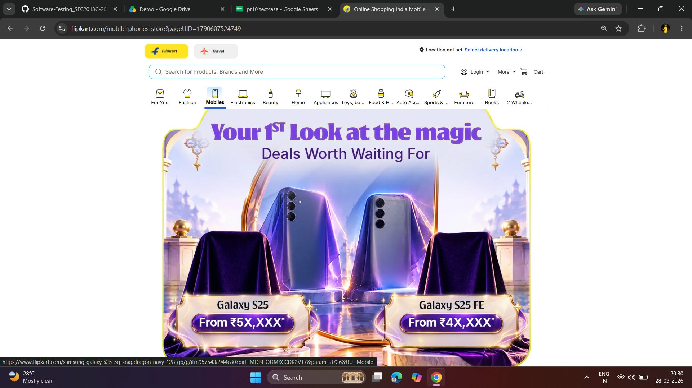

Test Case 2 – Product Search
Test Case ID: WB02
Test Case: Verify product search functionality
Test Steps: Open Flipkart and search for iPhone 18 Pro using the search bar.
Expected Result: Search results related to iPhone 18 Pro should be displayed.
Actual Result: iPhone 18 Pro search results were displayed successfully.
Status: PASS
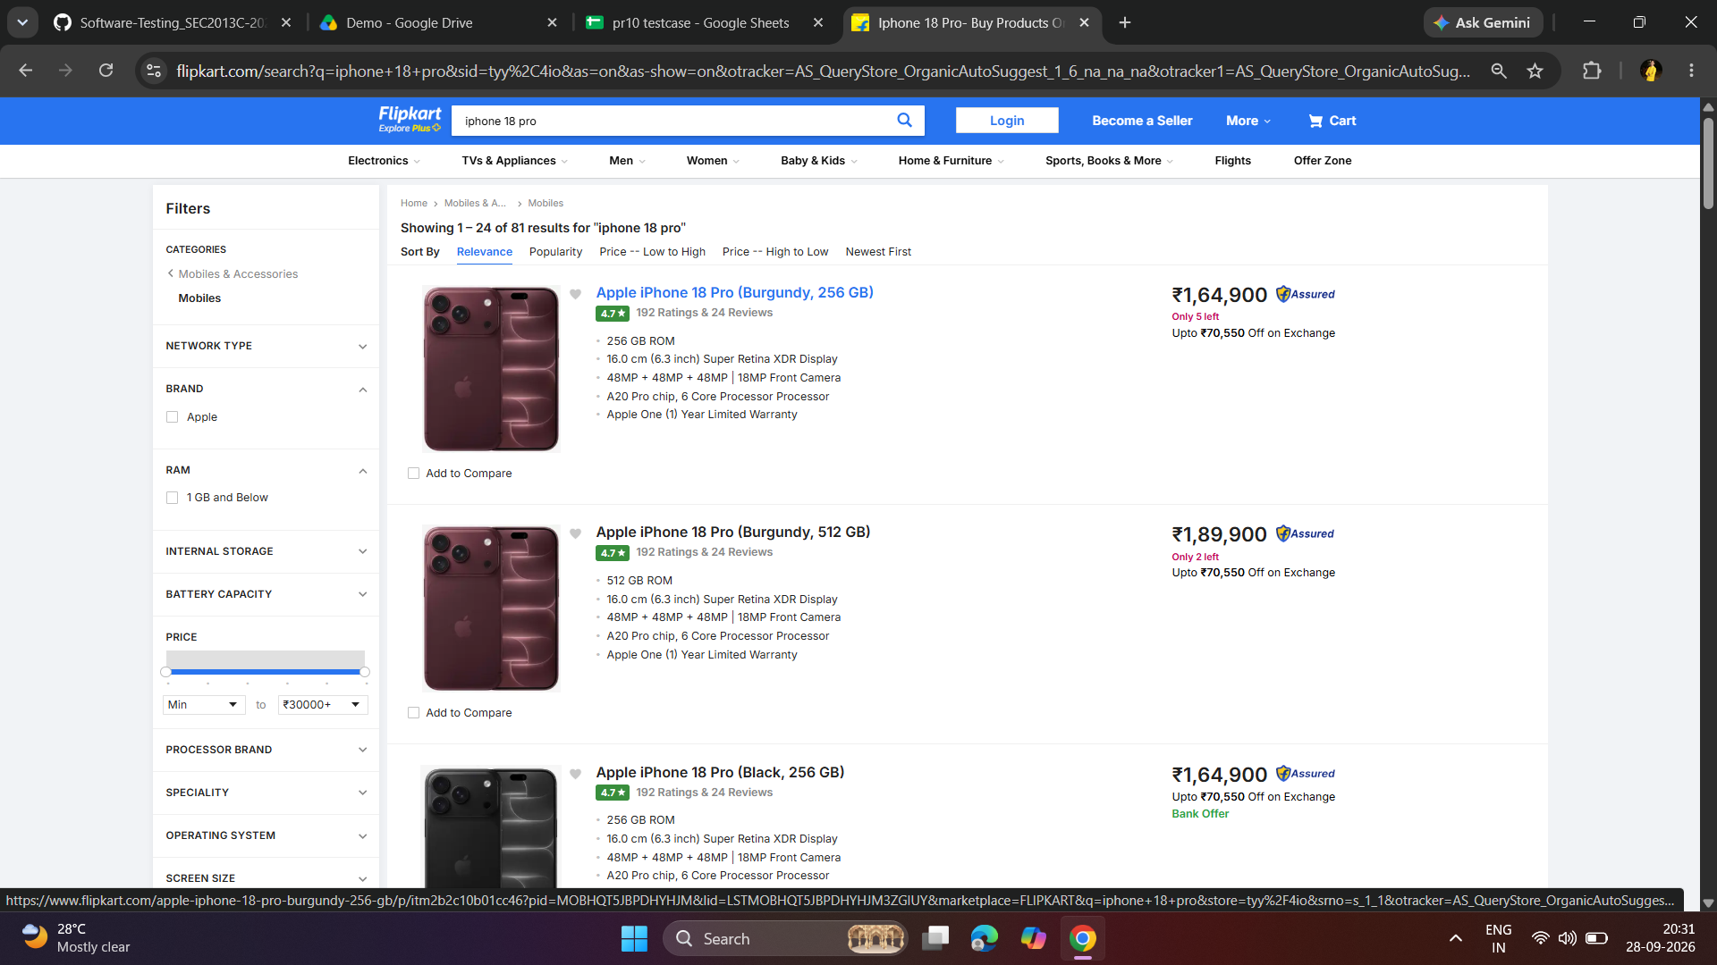

Test Case 3 – Search Results
Test Case ID: WB03
Test Case: Verify iPhone 18 Pro products are displayed
Test Steps: Search for iPhone 18 Pro and check the displayed product listings.
Expected Result: Relevant iPhone 18 Pro products should be displayed with product name, image and price.
Actual Result: iPhone 18 Pro products were displayed with product name, image and price.
Status: PASS
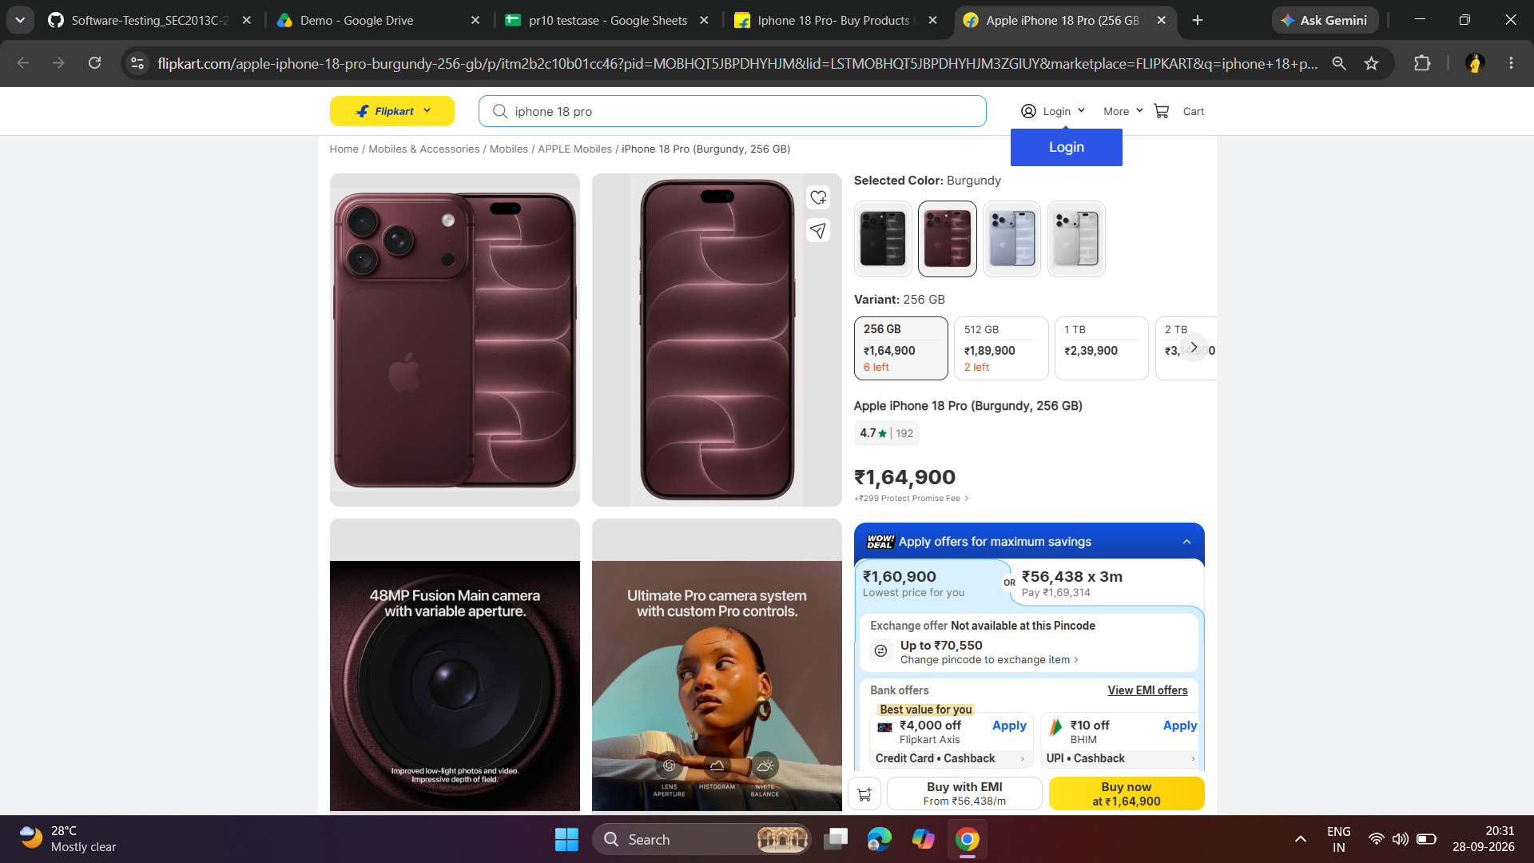

Test Case 4 – Product Details
Test Case ID: WB04
Test Case: Verify product details page
Test Steps: Select an iPhone 18 Pro product from the search results.
Expected Result: Product details page should be displayed with product image, variant, price and product information.
Actual Result: Product details page was displayed successfully with product image, variant, price and product information.
Status: PASS

Test Case 5 – Product Variant
Test Case ID: WB05
Test Case: Verify product storage variant selection
Test Steps: Open the iPhone 18 Pro product page and check the available storage variants.
Expected Result: Available storage variants such as 256 GB, 512 GB and other options should be displayed.
Actual Result: Storage variants were displayed successfully on the product page.
Status: PASS
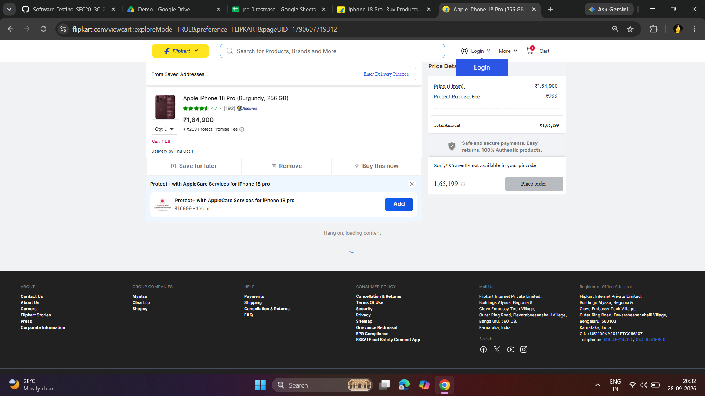

Test Case 6 – Add to Cart
Test Case ID: WB06
Test Case: Verify product is added to cart
Test Steps: Open the iPhone 18 Pro product page and add the product to the cart.
Expected Result: Selected iPhone 18 Pro should be added to the cart.
Actual Result: iPhone 18 Pro was successfully added to the cart.
Status: PASS

Test Case 8 – Login Page
Test Case ID: WB08
Test Case: Verify Flipkart login page is displayed
Test Steps: Click on the Login option from the Flipkart website.
Expected Result: Flipkart login page should be displayed with phone number/email login options.
Actual Result: Flipkart login page was displayed successfully with the phone number login option.
Status: PASS
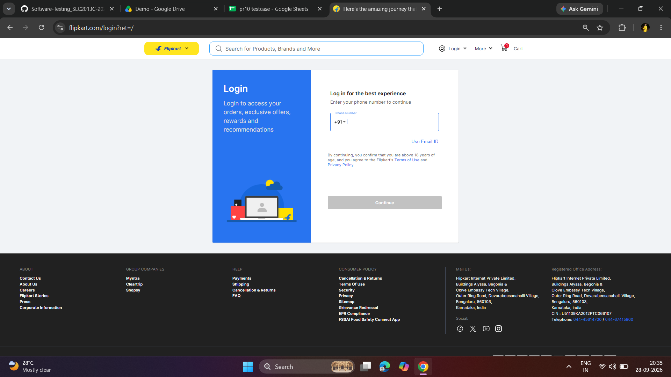

Test Case 9 – Automation Homepage Test
Test Case ID: WB09
Test Case: Verify homepage using Selenium automation
Test Steps: Run the flipcart.py Python Selenium script in VS Code.
Expected Result: Flipkart homepage should open successfully and the homepage test should pass.
Actual Result: Homepage opened successfully and the terminal displayed "Homepage Test: PASS".
Status: PASS
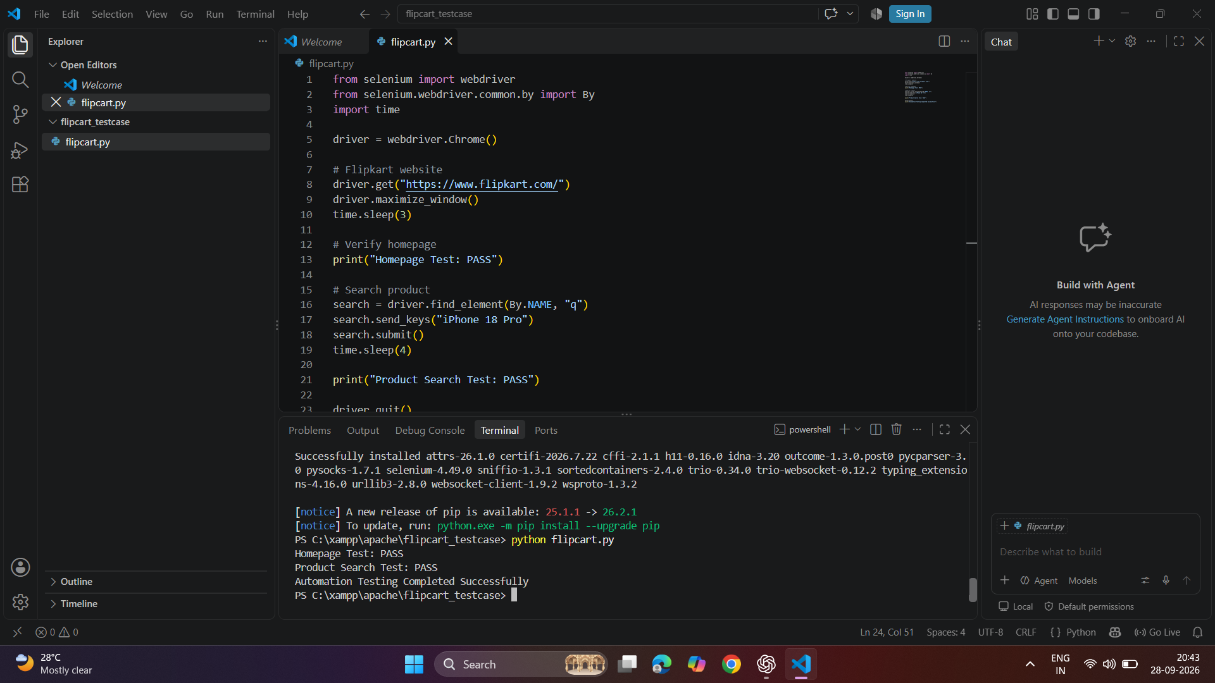

Test Case 10 – Automation Product Search Test
Test Case ID: WB10
Test Case: Verify product search using Selenium automation
Test Steps: Run the flipcart.py Selenium script and verify the automated product search.
Expected Result: Product search should execute successfully and the test should pass.
Actual Result: Product search was executed successfully and the terminal displayed "Product Search Test: PASS" and "Automation Testing Completed Successfully".
Status: PASS

